Hostel Room Booking and Fees Management System
Group Report

GROUP 19 MEMBERS

- WANYANA CHRISTIN VU-DIT-2603-1539-DAY
- KIRABO HILDAH VU-BIT-2603-1378-DAY
- ⁠BARUTI NDARABU Barly VU-BIT-2603-2237-DAY
- ⁠WAMUSI GRATIAN THADDEUS VU-BCD-2603-2670-DAY
- AXMED MUBAARAK MIRE VU-BIT-2603-0952-DAY
- KAMOGERERA LILLIAN VU-BBC-2603-3230-DAY
- 7. KHAWA DERICK JUNIOR VU-BSF-2603-2655-DAY
- MUGERWA JOSEPH VU-BSF-2603-2188-DAY
- MUKITE ELIZABETH VU-DIT-2603-0719-DAY

GitHub Link
The complete source code for this project has been uploaded to my GitHub account. The repository contains the full working Python file (hostel_booking_system.py).
GitHub Repository
Elizabeth-ui-py/HOSTEL-BOOKING-SYSTEM

Introduction
This report describes the design and implementation of a console-based Hostel Room Booking and Fees Management System, developed in Python by our group. The system allows a hostel warden to register students into hostel rooms, record and track fee payments, search for student records, generate occupancy and fee-defaulter reports, and persist all data to disk so that it survives a restart of the programme.
The remainder of this report covers the overall system design, how the work was divided among group members, and the main challenges we encountered while integrating our individual contributions into a single working system.
System Design
The system is built around two nested Python dictionaries, chosen because they naturally mirror the real-world structure of the problem:
- hostel_blocks which maps each block name (e.g. "Block 100") to a dictionary of its rooms; each room stores its capacity and a list of occupants' registration numbers.
- students which maps each registration number to a record containing the student's name, assigned block and room, total fee, amount paid, outstanding balance, and a list of individual payments.
Three hostel blocks are predefined at start-up, each containing three rooms of differing capacity, satisfying the requirement for a fixed set of blocks and rooms with maximum capacities.
The programme is organised into clearly separated functions grouped by responsibility, matching the six parts of the assignment brief with the group member that handled that part:
- Part a
Data setup: Kirabo Hildah handled this, it was to create hostel data build the initial blocks structure together with the print occupancy overview to show a summary on start-up of what is contained in each block alongside the room.

- Part b
Registration & allocation: This was handled by Wanyana Christine and Khawa Derrick, the code was to register student collect and validate warden input. If anything, wrong is inserted, the code keeps running based on the conditions that were put. The same code was to allocate rooms for students and enforce room capacity, in case a room is full, the warden gets a clear message hence prompting a student to be allocated to a different room. This code also creates the student's fee record at the first registration keeping track of the payment they ought to pay for a certain room.

- Part c
Fee payments: This was designed by Baruti Ndarabu Barly, the code is to record payment of a student. If a payment that is being made is a positive and a non- zero number, the programme acknowledges it, if the payment being made is negative and a zero number, the programme displays a clear message rather than crushing. It afterwards updates the payment against a student's outstanding balance.

- Part d
Search & reporting: This was handled by Thaddeus Gratian, the code is used to search student which basically looks up a student by name or registration number. If a name or registration number has not be registered before, a clear message appears which prevents the programme from crashing. It also views the block occupancy of a block alongside room and generates fee defaulters list, which shows the pending fees balance of a searched student against the threshold set. It then produces the two required reports.

- Part e
File persistence: This was handled by Kamogerera Lillian, this code’s role is to save data and load data while using the Python's json module to write and read the full system state as a single JSON file after information is input. It also builds a fresh database if the file is missing or corrupted rather than crushing.

- Part f
Menu-driven driver: This was designed by Mugerwa Joseph, this is a single looping main account that is displayed at the very start of the programme. Guides the user on what to input based on the information that they want access to. It has all the functions and variables connected to it.

Challenges that we faced
Inconsistent data models between contributions
Since everyone was individually typing their code when it got to assembling the code, it presented many errors. This was resolved wholly as a group where everyone’s work was reconciled by ensuring that we all had the same definitions of functions as well as the same variables. When this was done, the programme run smoothly.

Step-by-step Screenshots
Below are the screenshots taken while running the programme. Each screenshot shows an important part of the system working correctly.

Screenshot 1 – Main Menu
This is the main menu that appears after the program starts. The warden can choose any option from 1 to 7.
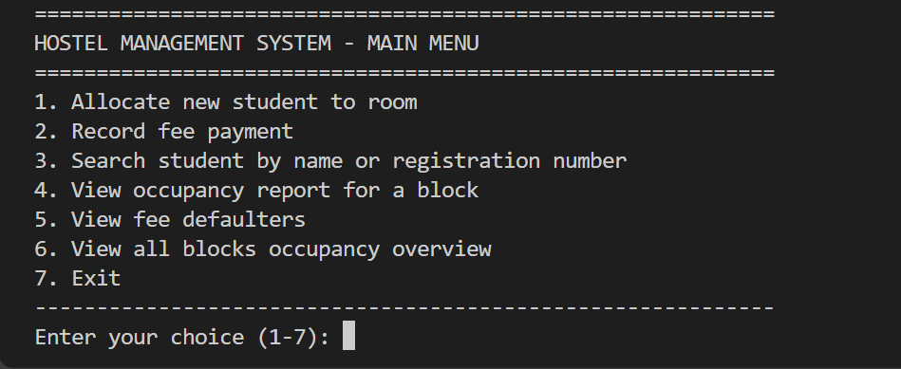

Screenshot 2 – Occupancy Overview (all blocks)
When the programme is opened it displays the occupancy overview for each block which includes the rooms occupied by the capacity and the percentage occupancy.
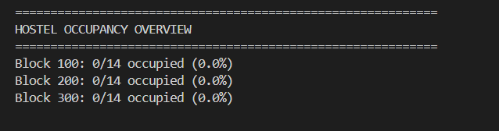

Screenshot 3 – Recording a Fee Payment (partial payment of 600000)
Student KIRABO (UG-40-AB) had a total fee of 800,000. A partial payment of 600,000 was recorded. The outstanding balance correctly became 200,000. This shows that partial payments work and the balance is updated correctly (requirement c).
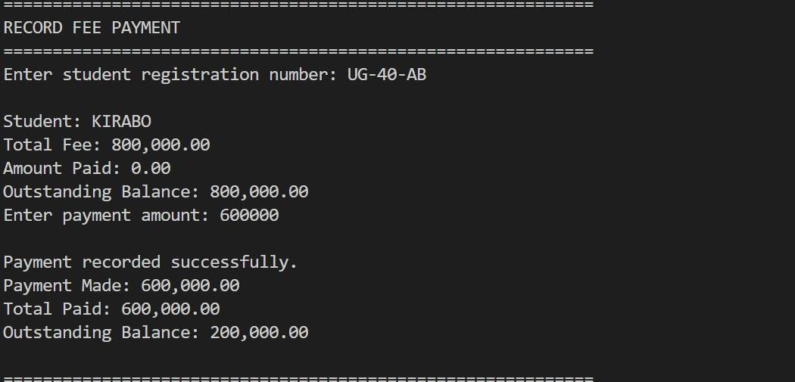

Screenshot 4 – Searching for a Student by Registration Number
After the payment, the student was searched using registration number UG-40-AB. The search result correctly shows the updated amount paid and the outstanding balance. This meets requirement (d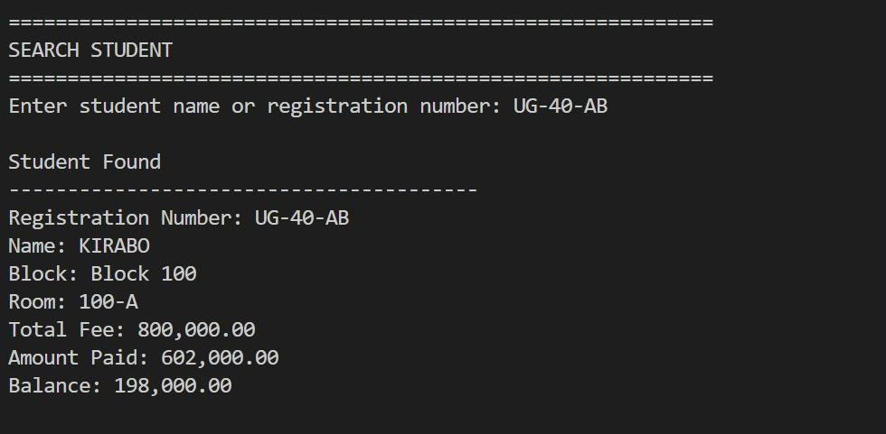

Screenshot 5 – Fee Defaulters Report (threshold 500000)
The fee defaulters report was generated using a threshold of 500,000. Students whose outstanding balance is above this amount are listed. This meets requirement (d).
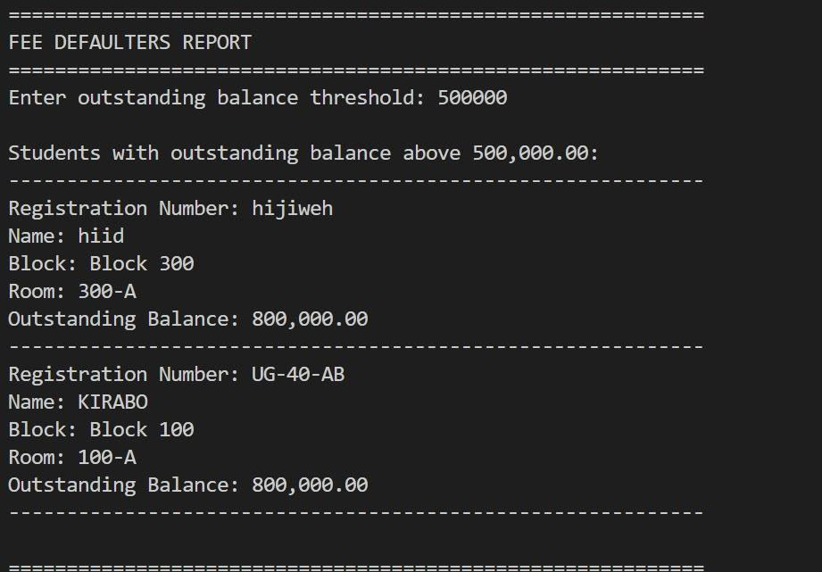
Screenshot 6 – Save & Exist Message
When option 7 is chosen the program displays a thank-you message and ends cleanly. Data is already saved so nothing is lost.
